🔥 Day 27 — NAT + Port Forwarding (Inbound Traffic Control)
🎯 Goal
👉 Understand:
How request from outside reaches your VM
👉 This is core cloud networking concept

🧠 Brutal Reality
Right now:
👉 Your VM in NAT mode = hidden behind router
Internet → Router → (stops here ❌)
Why?
Router doesn’t know WHICH VM to send traffic to

🔥 Concept: Port Forwarding
Public_IP:PORT → Private_IP:PORT
Example:
192.168.1.100:8080 → 192.168.1.50:8000

🧪 Step 1 — Confirm Current Behavior
Start server:
python3 -m http.server 8000 --bind 0.0.0.0

Test from host:
curl VM_IP:8000
👉 Likely ❌ (if NAT mode)
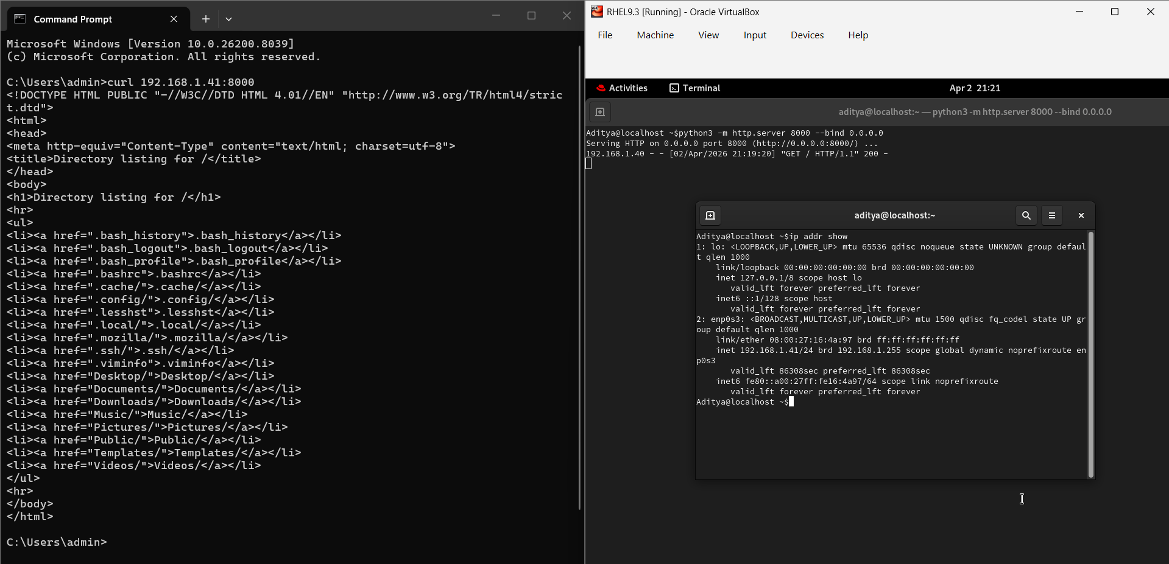

💥 Step 2 — Understand the Problem
VM has private IP
Router has public IP
Inbound traffic stops at router

🔧 Step 3 — Fix (VirtualBox NAT Port Forwarding)
Go to:
👉 VM Settings → Network → NAT → Advanced → Port Forwarding
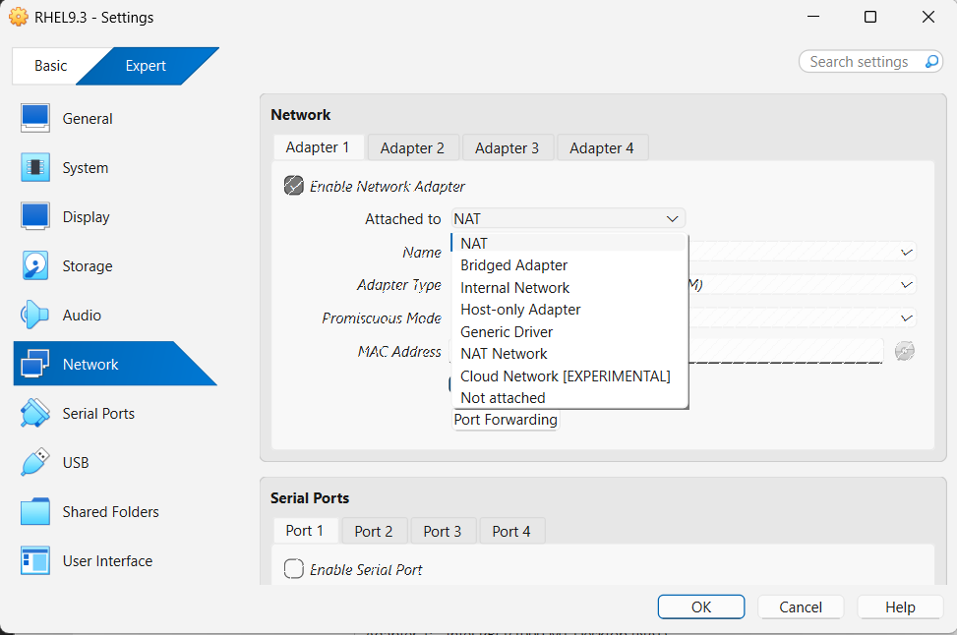
Add Rule:
Name | Protocol | Host IP | Host Port | Guest IP | Guest Port
web | TCP | 127.0.0.1 | 8080 | VM_IP | 8000
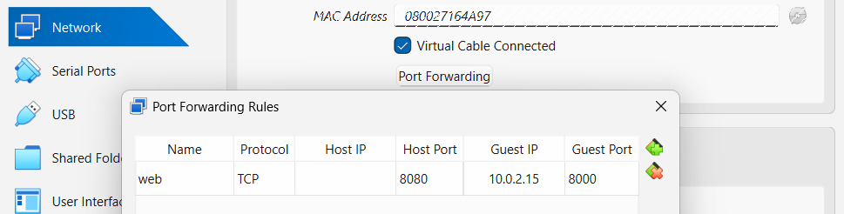
IN VM -> Run “init 6” (VIMP)

🧪 Step 4 — Test Again
From your host:
curl localhost:8080
✔ Should work
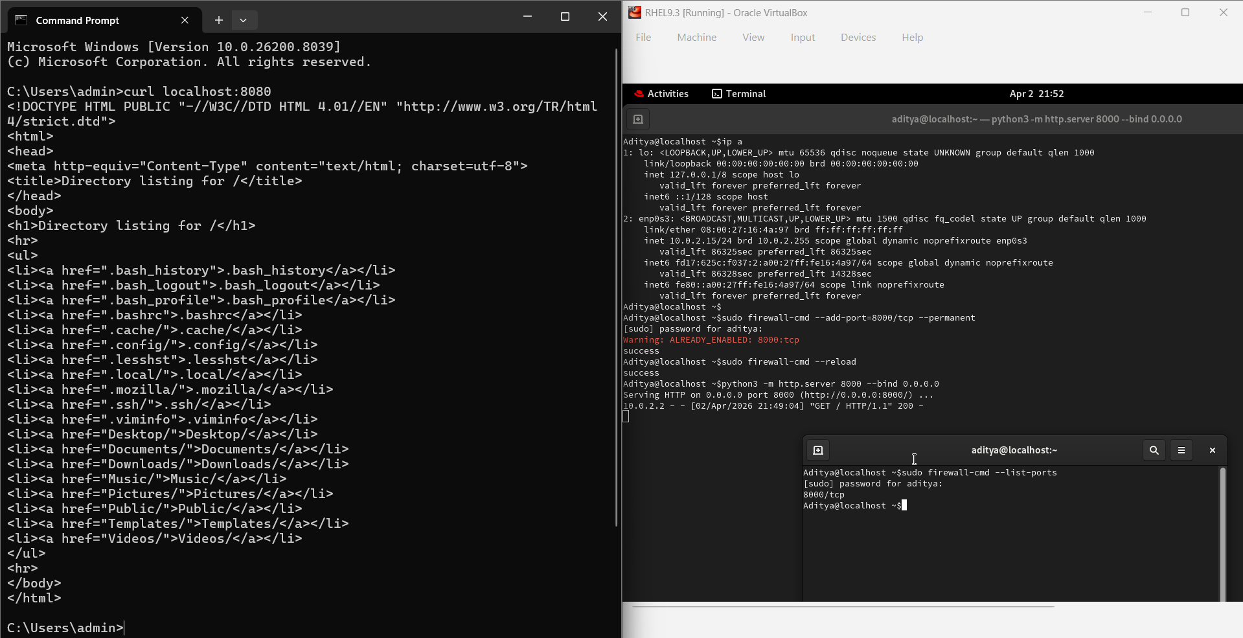

🧠 What Just Happened
Request → Host (8080)
→ Router (NAT)
→ Forwarded to VM (8000)
→ Response comes back

🔥 Step 5 — Verify Listening
Inside VM:
ss -tulnp | grep 8000

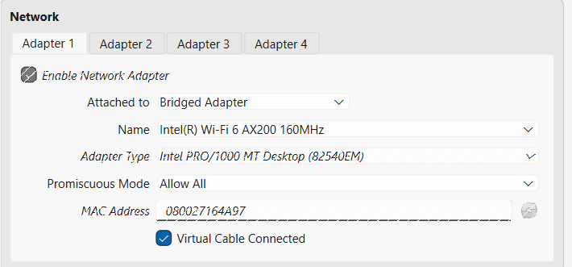
🔥 Step 6 — Break It Again (Learning > Comfort)
Remove forwarding rule
Now test:
curl localhost:8080
❌ Fails again
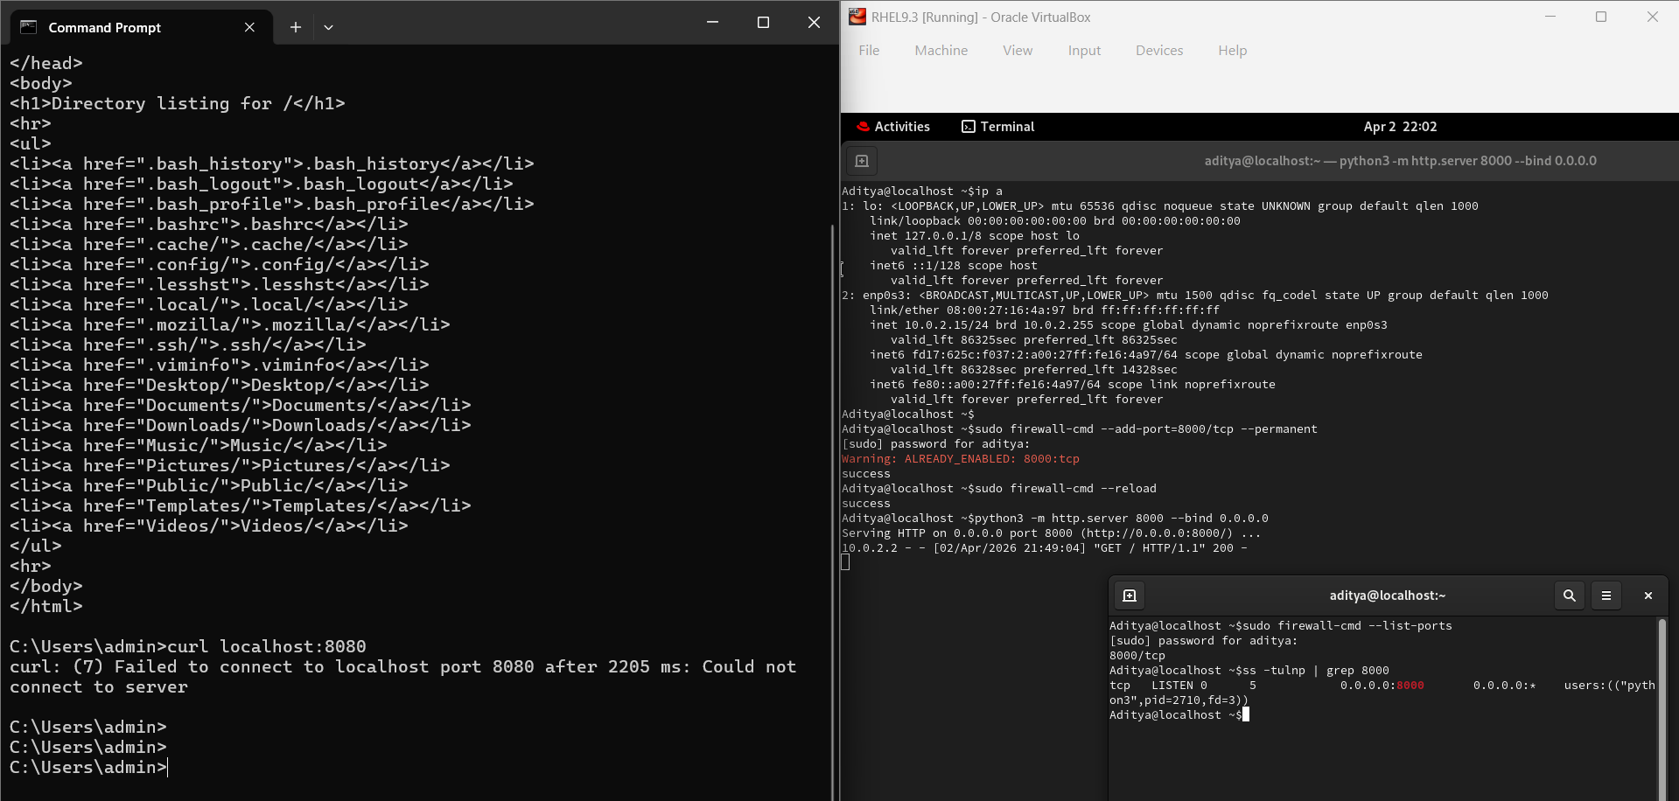

👉 This proves:
NAT blocks inbound by default

🧠 What You Must Write Today
Core Concept
NAT allows outbound traffic by default
Blocks inbound traffic unless port forwarding is configured

Flow
Client → Public IP → NAT → Port Forward → VM → Response

Key Insight
Without port forwarding, external systems cannot reach your VM

Real World Mapping (IMPORTANT)
Port Forwarding = AWS Security Group + Public IP
NAT = NAT Gateway behavior

✅ Expected Output (Day 27)
You should have:
✔ Understood NAT inbound limitation
✔ Configured port forwarding
✔ Accessed VM service from host
✔ Broken and re-tested
✔ Written full flow

🔥 Day 27: NAT + Port Forwarding (Inbound Traffic Control)
🎯 Objective
To understand how to access a service (Web Server) running inside a private, isolated Virtual Machine from the outside world (Host Machine).

🧠 Core Concepts
- NAT (Network Address Translation): Acts like a one-way mirror. The VM can see the internet (Outbound), but the internet cannot see the VM (Inbound).
- Port Forwarding: The "Doorway" in the NAT wall. It maps a specific port on the Host IP to a specific port on the Guest (VM) IP.
- The "Hidden" Reality: By default, a VM in NAT mode is invisible to the Host. Even if a service is running, the Host doesn't know how to route traffic to it.

🔧 The Practical Workflow
- Service Setup (VM): Started a Python Web Server on Port 8000.
  - Command: python3 -m http.server 8000 --bind 0.0.0.0
- Internal Security (VM): Opened the RHEL Firewall to allow traffic.
  - Command: sudo firewall-cmd --add-port=8000/tcp --permanent && sudo firewall-cmd --reload
- The Bridge (VirtualBox): Configured a Port Forwarding Rule.
  - Rule: Host Port 8080 \(\rightarrow \) Guest IP 10.0.2.15 \(\rightarrow \) Guest Port 8000.
- Verification (Host): Accessed the VM via the Host's loopback address.
  - Command: curl localhost:8080

🧪 Verification Commands (The "Checklist")
- ip addr: Used to find the VM's internal NAT IP (usually 10.0.2.15).
- ss -tulnp | grep 8000: Confirmed the OS is actually listening on the port.
- curl localhost:8080: The final proof of connectivity from the outside.

💡 Key Insights & Real-World Mapping
- NAT Gateway: In AWS/Cloud, a NAT Gateway allows private instances to get updates but blocks hackers from getting in.
- Security Groups: Port Forwarding is similar to adding an "Inbound Rule" to an AWS Security Group or Azure NSG.
- The "Break" Lesson: If you delete the Port Forwarding rule, the service is still running perfectly inside, but it becomes unreachable from the outside. Connectivity requires both the Service and the Route.

🔍 The Port Confusion: 8080 vs. 8000
Think of it like an Apartment Building:
- Port 8000 (The Apartment): This is the specific room inside the VM where your Python server is sitting.
- Port 8080 (The Building Entrance): This is the door on your Host (Windows) computer.
- The Connection: Since Windows can’t "see" inside the VM's private room directly, you told VirtualBox: "If someone knocks on my front door (8080), take them straight to the VM's room (8000)."

🎯 What was the Aim?
To prove that NAT (Network Address Translation) is a one-way street.
- Outbound works: Your VM can go out to the internet to download updates.
- Inbound is blocked: The internet (and even your own Host) cannot get into the VM unless you explicitly create a "Port Forwarding" rule.

🧠 What We Learned (The 3 Pillars)
- Isolation: A VM in NAT mode is hidden behind a virtual router.
- Firewalling: Even if the router allows traffic, the VM’s internal firewall (firewalld) must also be told to "Open the Door."
- Binding: You must bind a service to 0.0.0.0 (all interfaces) so it listens for external requests, not just its own internal ones.

🌍 Why is this Important? (Real World)
This is exactly how Cloud Networking (AWS/Azure/GCP) works:
- Security: You don't want every database or server exposed to the whole internet. You keep them in a "Private Subnet" (NAT).
- Access: When you do need to reach a private server (like a website), you use a Load Balancer or a Public IP with a specific port rule—just like the Port Forwarding you did today.

Summary for your Log:
"Today I learned that NAT provides security by obscuring the VM, and Port Forwarding provides controlled access by mapping a Public-facing port to a Private-facing service."

📘 Day 27 — NAT + Port Forwarding (Inbound Traffic Control)

🎯 Objective
Understand how a request from outside reaches your VM — and why it doesn't by default.

🧠 Core Concepts
NAT (Network Address Translation):
- Acts like a one-way mirror
- VM can access the internet (outbound ✔)
- Internet cannot reach the VM (inbound ❌)
Port Forwarding:
- The "doorway" in the NAT wall
- Maps a Host port → Guest (VM) port
- Example: Host 8080 → VM 8000
The Hidden Reality:
- A VM in NAT mode is invisible to the Host
- Even if a service is running inside, the Host can't route traffic to it without port forwarding

🔧 Practical Workflow (What We Did)
Step 1 — Start a Web Server inside VM:
python3 -m http.server 8000 --bind 0.0.0.0
Step 2 — Open the VM Firewall:
sudo firewall-cmd --add-port=8000/tcp --permanent
sudo firewall-cmd --reload
Step 3 — Configure Port Forwarding (VirtualBox):
- VM Settings → Network → NAT → Advanced → Port Forwarding
- Add rule:
Name | Protocol | Host IP | Host Port | Guest IP | Guest Port
web | TCP | 127.0.0.1 | 8080 | 10.0.2.15 | 8000
⚠️ After adding the rule → Reboot VM (init 6)
Step 4 — Test from Host:
curl localhost:8080
✔ Should return directory listing from VM
Step 5 — Verify VM is Listening:
ss -tulnp | grep 8000
Step 6 — Break It (Remove forwarding rule):
curl localhost:8080
❌ Fails → Proves NAT blocks inbound by default

🔀 Traffic Flow
Client → Public IP:8080 → NAT → Port Forward → VM:8000 → Response back

🏢 The Port Confusion: 8080 vs 8000 (Apartment Analogy)
Port | Role | Analogy
8000 | VM's internal service port | The apartment (room inside)
8080 | Host's external-facing port | The building entrance (front door)
VirtualBox rule = "If someone knocks on door 8080, take them to room 8000"

🧠 The 3 Pillars We Learned
- Isolation — VM in NAT mode is hidden behind a virtual router
- Firewalling — Even if router allows traffic, VM's firewall (firewall) must also open the port
- Binding — Service must bind to 0.0.0.0 (all interfaces), not just 127.0.0.1

🌍 Real-World Cloud Mapping
Lab Concept | Cloud Equivalent
NAT mode | NAT Gateway / Private Subnet
Port Forwarding | AWS Security Group Inbound Rule / Azure NSG
Removing forwarding rule | Deleting Security Group rule

🔑 Key Insight
Without port forwarding, external systems cannot reach your VM. Connectivity requires both the service running and the route configured.

✍️ Summary for Notebook
"NAT provides security by hiding the VM. Port Forwarding provides controlled access by mapping a public-facing port to a private-facing service."

✅ Checklist
- ✔ Understood NAT inbound limitation
- ✔ Configured port forwarding in VirtualBox
- ✔ Accessed VM service from host via curl
- ✔ Broke and re-tested to confirm
- ✔ Written full traffic flow

